UKG – A
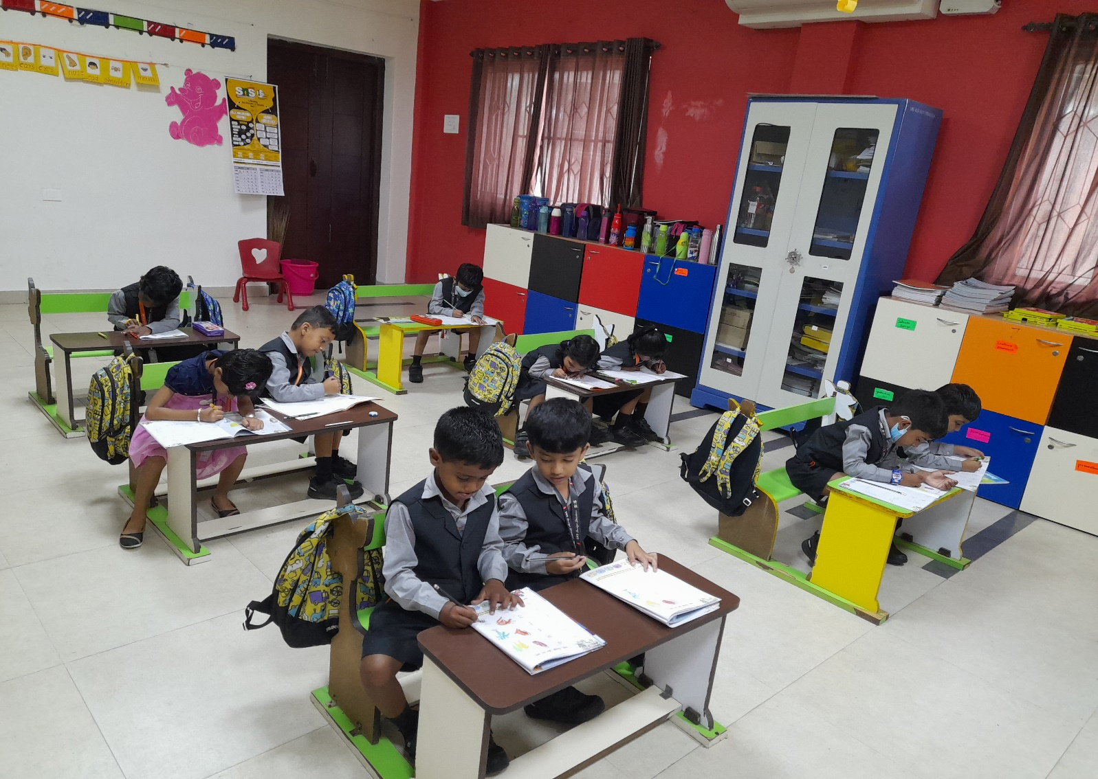
HINDI COLOURING ACTIVITY

